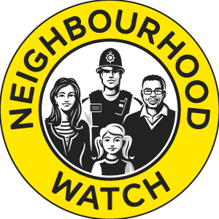
YOUR WATCH NAME
NEIGHBOURHOOD WATCH
Please can you complete this form for our information: All details are given in the strictest confidence and will only be used by the YOUR WATCH NAME Neighbourhood Watch and MET Police Safer Neighbourhood Team for their sole use.. By signing this form you agree for your information to be shared amongst the MET Police and Neighbourhood Watch
BASIC INFORMATION
Title | Mr/Mrs/Miss/Ms/Rev/Other
First Name
Surname
Date Of Birth
Address
Postcode
Tel (Home)
Tel (Mobile)
Email Address

In the Neighbourhood Watch we have a couple of roles:
- a co-ordinator, who runs the watch for his or her road/s, blocks etc
- a member who doesn’t want to co-ordinate but would like to join and become part of the scheme

Please indicate below what you are interested in doing:
- Coordinator
- Member

If you become a coordinator please agree that you will only use Coordinator and Member details for the purpose of Neighbourhood Watch scheme.
I confirm that I am agreeing to join the YOUR WATCH NAME Neighbourhood Watch Scheme in the capacity indicated above.

______________________________ __________________
SIGNATURE DATE

